Task: Zero-Trust Security for a University Network
Task Overview:
This project builds a zero-trust network for a university with three user roles: students, lecturers and administrators. No user or device is trusted because of where it plugs in. Every request is checked against a written policy and anything not explicitly allowed is denied.
- Design and topology - Roles, devices, addressing, permission model
- Segmentation - VLANs, trunk, router-on-a-stick
- Identity and authentication - AAA with local accounts on router and switch
- Device enrolment and wireless - Port security, sticky MAC, wireless access point
- Role-based policy - Four extended ACLs with default deny
- Testing and compromise scenarios - 17-test matrix, 5 attack scenarios, logging, traffic analysis
- Conclusion and problems faced

Phase 1: Design and topology

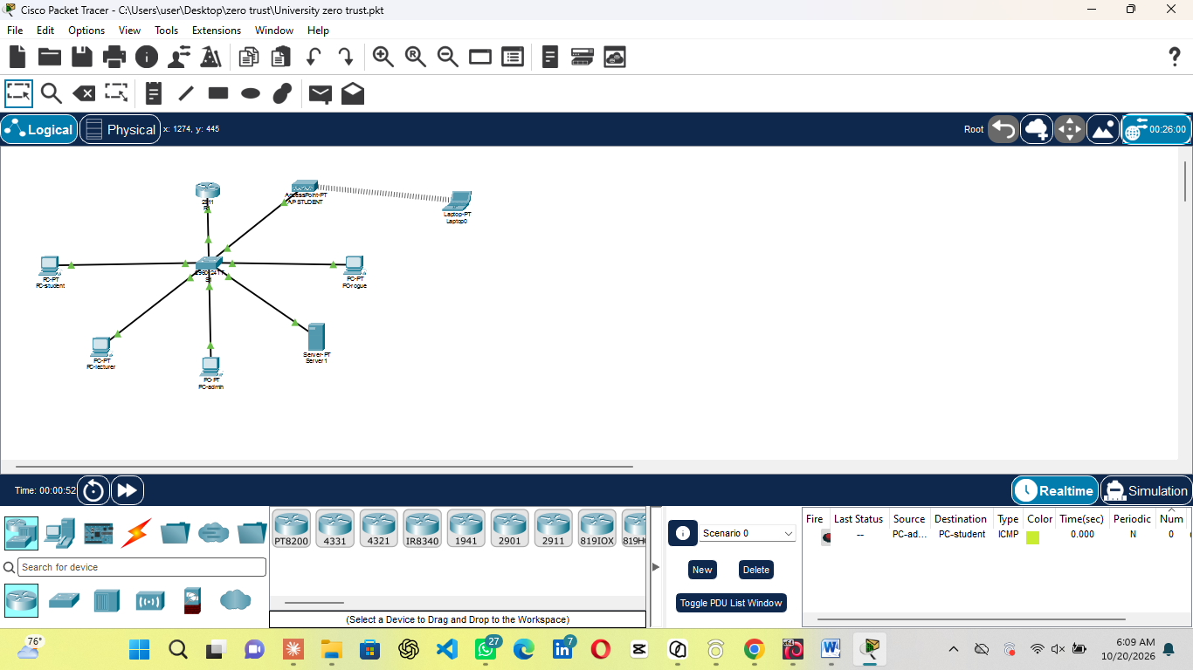
The design uses one router and one switch. Each role has its own VLAN, and R1 holds one sub interface per VLAN.

Permission model. Everyone enrolled can reach the portal. Lecturers and administrators can also reach the records system. Only administrators can manage devices.

Phase 2: Segmentation
S1 defines VLANs 10, 20, 30, 40 and 99 and assigns one access port to each role. Fa0/1 is the trunk to R1. On R1, five sub interfaces give each VLAN its own gateway.
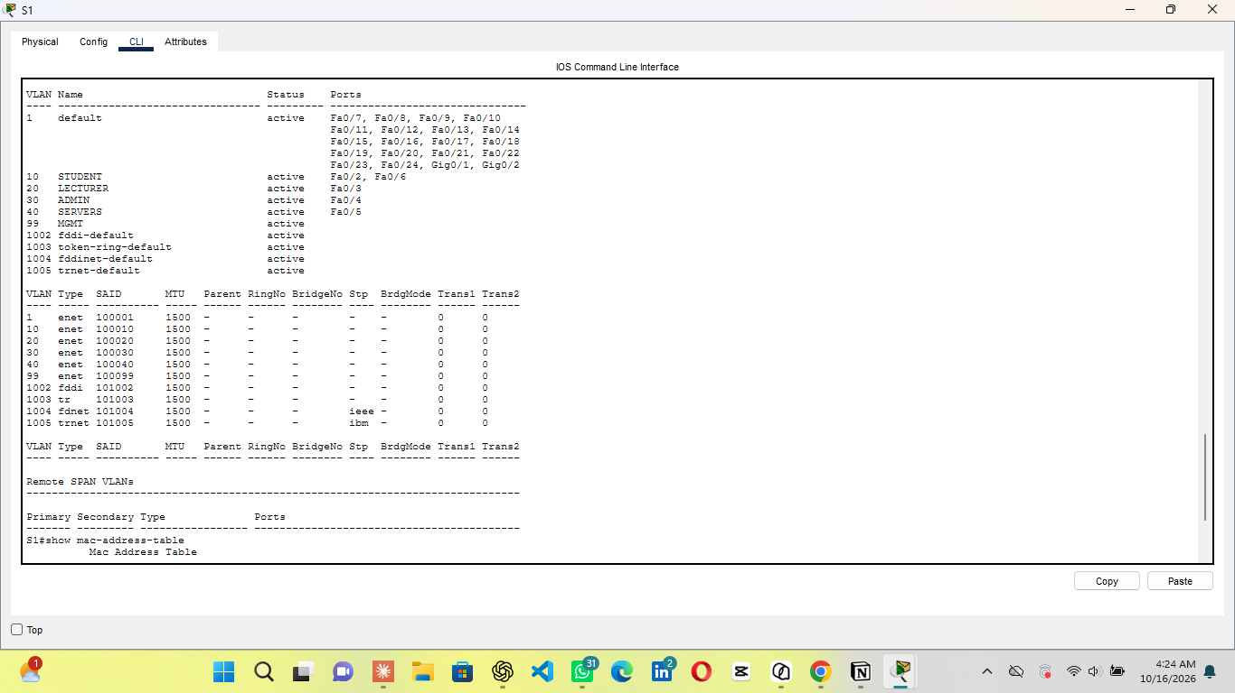

Phase 3: Identity and authentication
Both devices use AAA against a local user database with three accounts (admin, lecturer, student). Applying AAA to the default login method covers the console as well as the telnet lines, so physical access alone gives nothing. Secrets are stored as hashes.
The console and telnet both open with User Access Verification.
Wrong credentials are refused with % Login invalid.

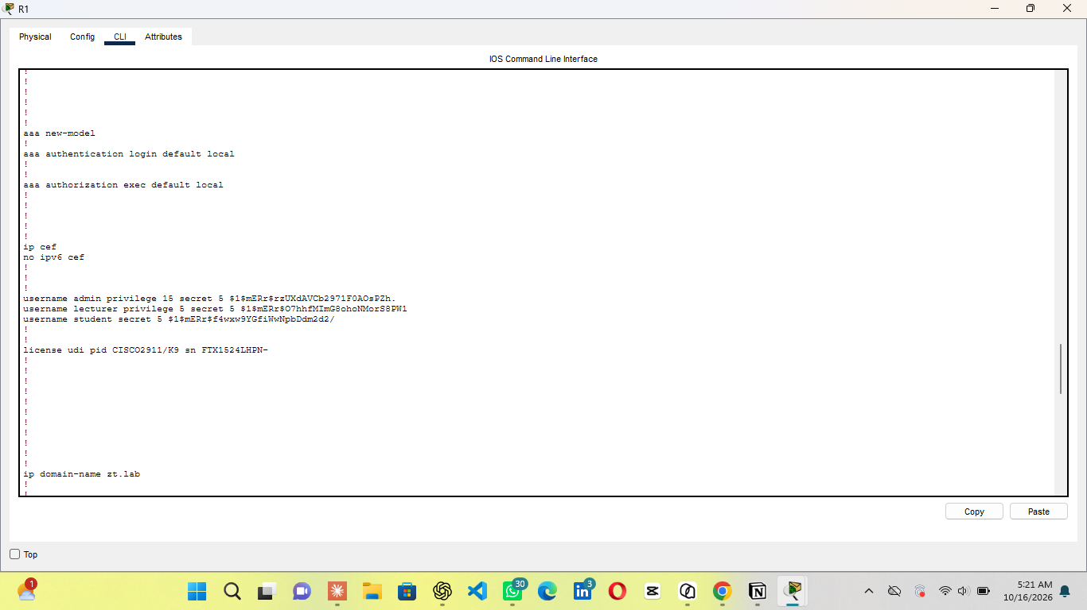

Phase 4: Device enrolment and wireless
Port security with sticky MAC learning pins one hardware address to each enrolled port (maximum 1, violation shutdown). A device swap on an enrolled port is refused and the port shuts down. The wireless access point sits on Fa0/7 in VLAN 10 with WPA2-PSK/AES, so wireless students get exactly the same policy as wired students. That port allows two addresses and pins the laptop’s own MAC.
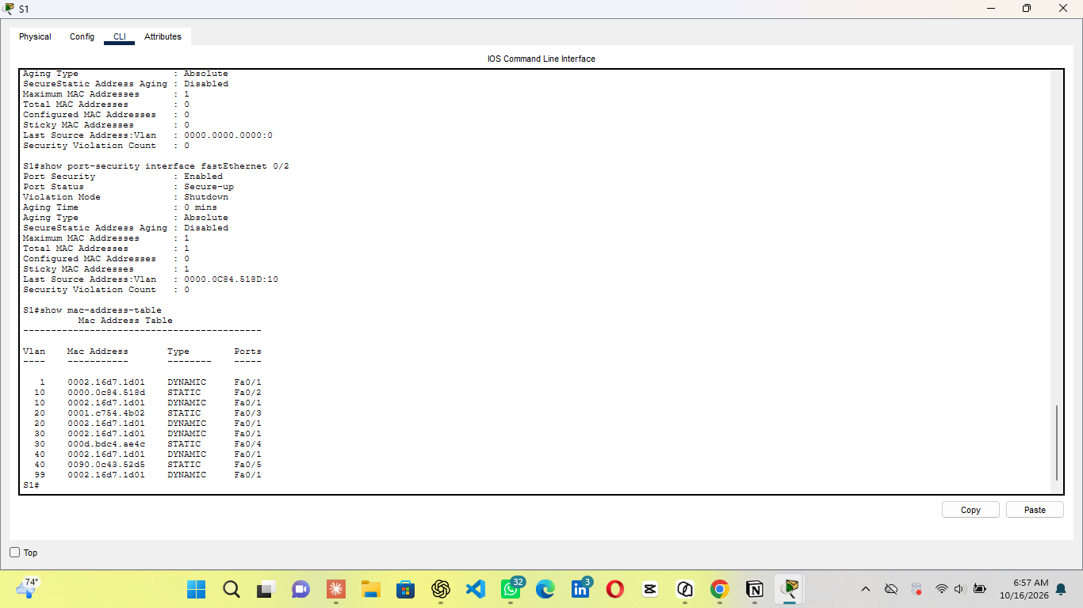

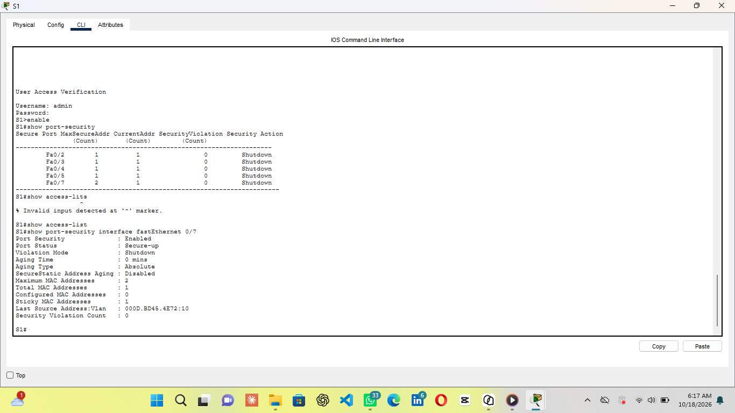

Phase 5: Role-based policy
One named extended ACL per role is applied inbound on that role sub interface: STUDENT-IN, LECTURER-IN and ADMIN-IN, plus SRV-IN on the server segment, which allows replies but never new connections. Each list ends with an explicit deny ip any any. Two ordering rules mattered. The student echo-reply permit must sit above the role deny, or the administrator ping dies on its return path. The default deny must be the last and highest-numbered line, or it hides the rules below it.
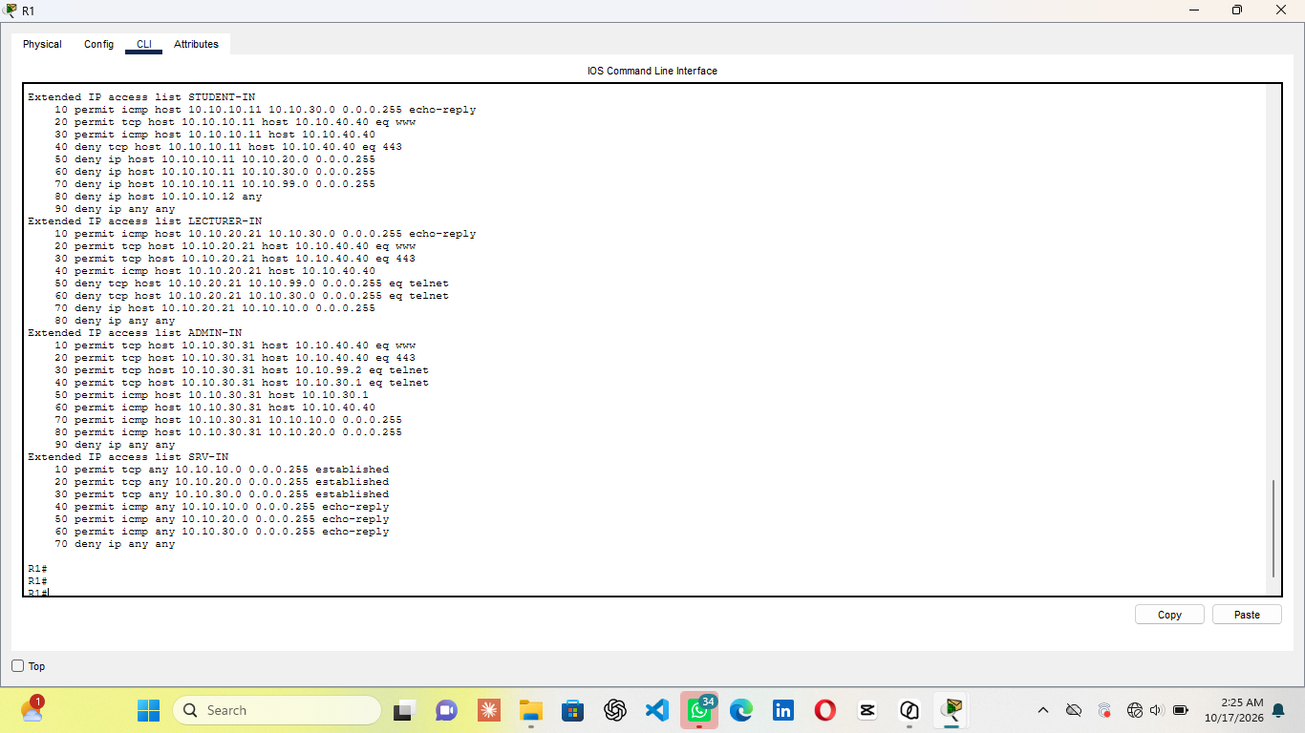
Phase 6: Testing and compromise scenarios
Seventeen tests were run from the end devices themselves, and all returned the expected verdict. The same destination gave opposite answers by role: a student gets nothing from https://10.10.40.40 while a lecturer gets the page.
http://10.10.40.40: Student - Permitted
https://10.10.40.40: Student - Denied
https://10.10.40.40: Lecturer - Permitted
telnet 10.10.99.2: Student / Lecturer - Denied, no login prompt
telnet 10.10.99.2: Admin - Permitted, login prompt shown
ping from server to student: Server1 - Denied by SRV-IN

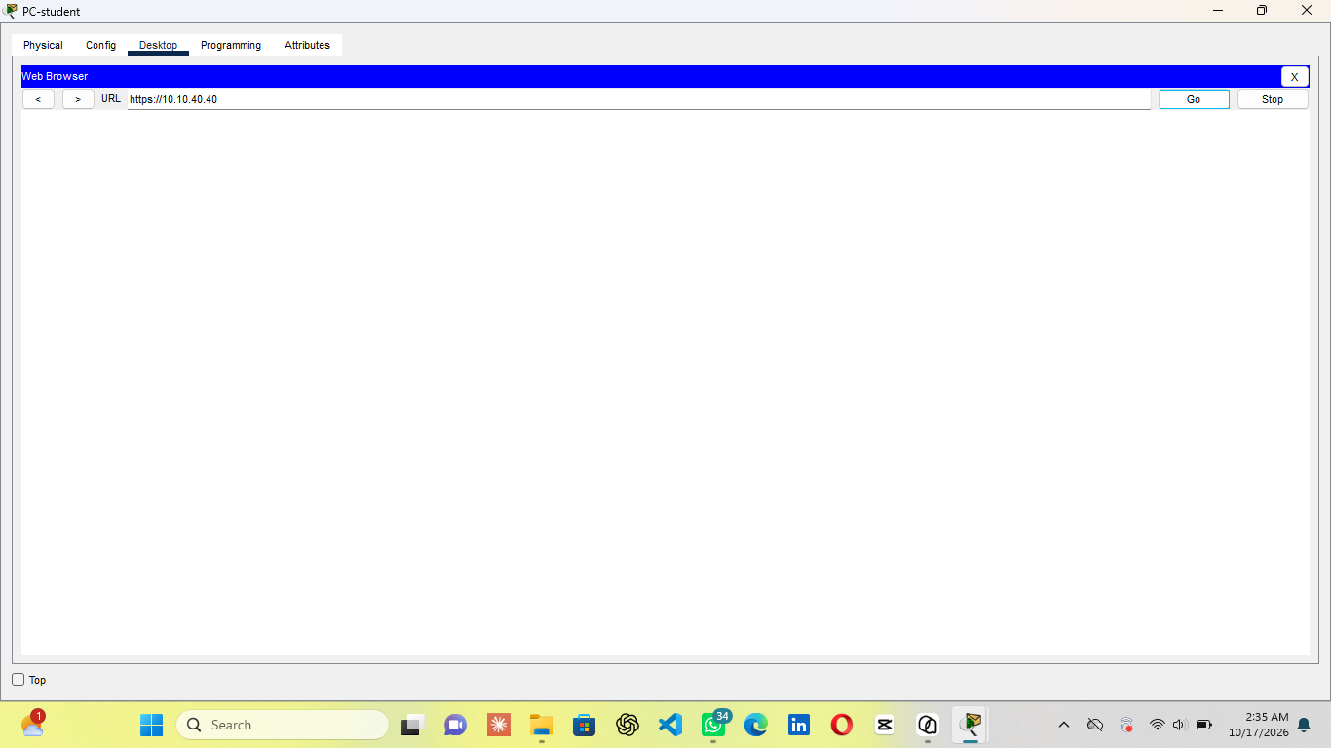

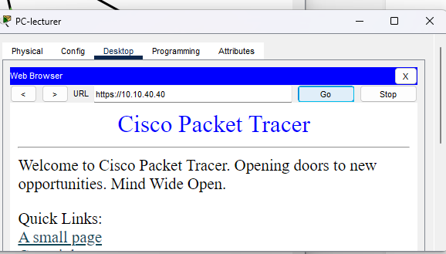

The switch logs violations naming the rejected MAC and port. The router counts matches per rule, including 18 matches on the final default-deny line, which proves that rule actually fired.
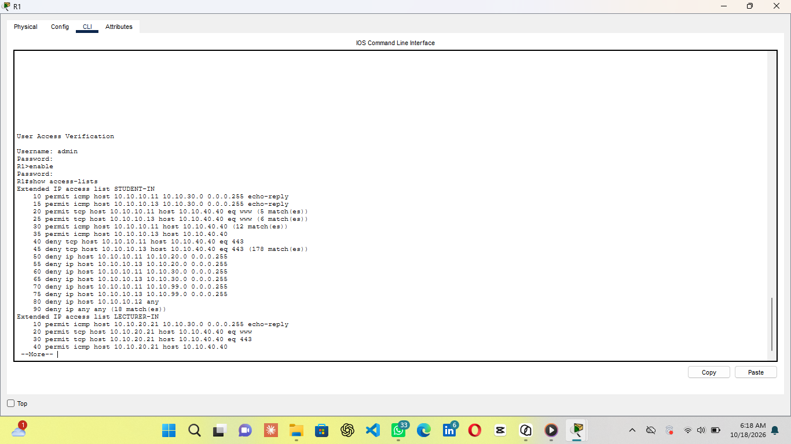

Traffic analysis: Packet Tracer Simulation mode showed the same HTTP packet untagged on the student access port and tagged on the trunk, with the router’s MAC as destination. This confirms that all cross-VLAN traffic is mediated by the policy point.
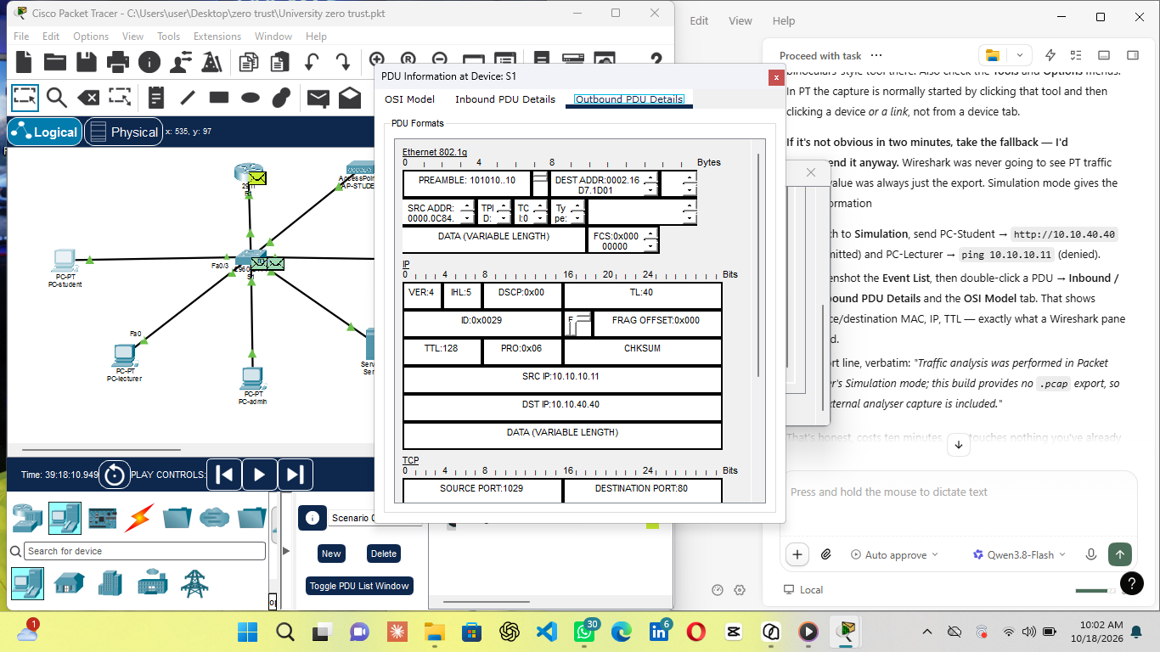

- Device swap on enrolled port contained -port shut down attacker got no access
- Stolen ip address not contained rogue took the student address and reached the server

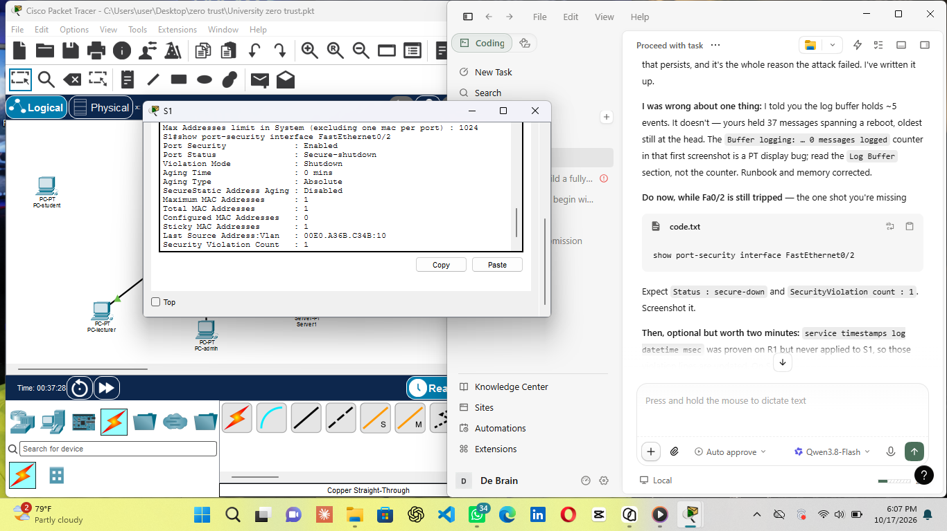
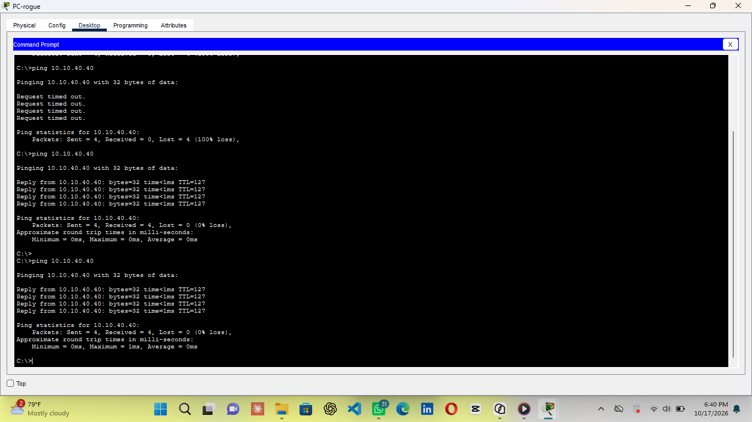

Phase 7: Conclusion and problems faced
Conclusion:
The architecture built here does what a zero-trust design must do at the layer a network engineer controls. it trusts no location, it decides per flow against explicit role policy, it defaults to denial and can show the denial firing, it binds the access port to a known device and refuses substitutes, and it records what it decided. All seventeen policy tests and five compromise scenarios were executed against the running configuration and reported as observed.
It also shows, at the same level of evidence, where that stops. A stolen address was accepted, and same-segment traffic was unpoliced
Problems faced:
ACL log keyword rejected: No per-packet ACL log lines possible - Used rule match counters and switch logs
Privilege levels ignored: All users logged in at level 1 and could use one enable secret - Claimed containment from reachability only, not authorisation

